NAME:

JOB TITLE: Consultancy Administrator

REPORTING TO: Consultancy Manager

Continuous employment since:

This post since: Grade: Assistant Officer

- Job Purpose

To provide administrative support to the Devon Wildlife Consultants team with a strong focus on financial and administration tasks delivered in a busy environment.

- Dimensions

- This post is a permanent part-time (22.5 hours per week) role based at DWT offices at Aldens Court, Alphington, Exeter.
- Member of the Devon Wildlife Consultants team, which is part of Devon Wildlife Enterprises, a trading subsidiary of Devon Wildlife Trust, and will be line managed by the Consultancy Manager.
- The postholder will assist with the management of volunteers and sub-contractors.
- The postholder has no line management responsibility.
- The postholder has no budgetary responsibility.

- Background

DWC is an ecological consultancy owned and operated by the Devon Wildlife Trust through its commercial arm, Devon Wildlife Enterprises Ltd (DWE). All of DWE’s profits are gift aided to Devon Wildlife Trust to further its conservation work.

DWC undertakes a range of work relating to all aspects of ecological consultancy, including UKHab baseline surveys, Biodiversity Net Gain (BNG) assessments and species surveys, and monitoring for a range of commercial and conservation projects.

The administrator will support the busy and growing team at DWC by carrying out office, financial and team scheduling tasks. There will be a focus on financial administration tasks, responding to general enquiries, assisting with the promotion of DWC and overseeing the bat survey schedule and project management system for the team.

Principal Accountabilities

The most important tasks that the postholder will be expected to undertake in their day to day work are: -
- Be the first point of contact and responding to general enquiries by email and telephone;

- Financial tasks including using Xledger for raising purchase orders, invoicing and undertaking debt-chasing in line with DWC procedures, assisting with financial analysis;

- Assist with the promotion and marketing of DWC by collating regular marketing e-newsletter content, LinkedIn and website updates;

- Assist with management of the team bat survey schedule, including co-ordinating surveyors and subcontractors;

- Monitor Health & Safety compliance checks and maintenance of records, reporting issues to Facilities;

- Monitor survey equipment and stationery levels and make sure that the stock levels are adequate and supplies are maintained;

- Book travel tickets, training courses and accommodation for staff as required;

- Support training, marketing and client events and workshops including venue planning, taking bookings and providing support on the day;

- General liaison between DWC and DWT’s central office teams, including Facilities and Finance, and other DWT teams such as Working Wetlands;

- Any other administrative tasks to support the team, as can be reasonably required as part of this post.

In the course of delivering this work the postholder will need to have regard to:

- Be an ambassador for the DWC team and DWT;

- The need to act as champion for DWT’s standards and values;

- Working with due regard to Health and Safety, Environmental Management, the General Data Protection Regulations, Safeguarding, IT/AI and other organisational policies and procedures;
- Current legislation and policy, best practice guidelines and health and safety procedures;

- Current CIEEM code of conduct and guidelines;

- Customer care and service standards;
- Being willing to undertake other tasks as reasonably requested.

- Person Specification

 | Essential | Desirable
Skills & attributes | Ability to provide clear, concise written material | Ability to assist in setting up technical documents
 | Excellent IT skills including Microsoft 365 | Experience of AI tools
 | Flexible and enthusiastic attitude to work, able to work as a member of the team both in person and remotely
 | Ability to work efficiently and on own initiative, to manage and prioritise own workload | Multi-tasking skills / project management (any level)
 | Good communication skills, both written and verbal, including excellent telephone manner | Ability to use social media, Wordpress and other applications for business promotion
 | Ability to build relationships and act as a friendly and professional frontline contact for DWC | Interest in environmental consultancy and nature conservation
 | Ability to work under time pressure in a busy and dynamic environment
Knowledge & qualifications | Educated to A Level standard or equivalent post-16 qualification. | Relevant qualification in business administration e.g. NVQ level 3
 |  | Full driving licence
Experience | Minimum of 6 months experience in a similar administration role | Previous experience of working or volunteering on a conservation or environmental project
 | Experience of customer/client service | Experience of working with a wide variety of clients, stakeholders volunteers and/or members of the public
 | Experience of financial administration tasks, including use of finance packages | Experience of using Xledger
 | Experience of assisting with team scheduling

- Reporting Structure

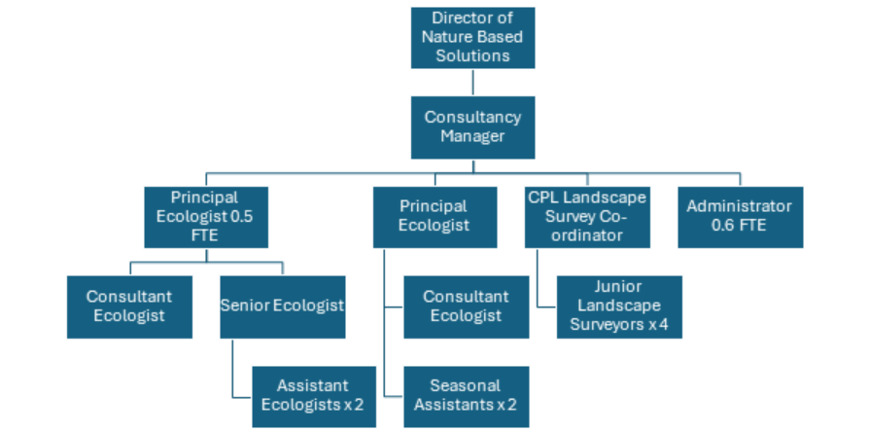

- Working Relationships

Internally the postholder will:

- Work closely with colleagues and volunteers within the consultancy.
- Be able to build relationships with all DWT staff, particularly the finance and communications teams.

In order to deliver tasks and maintain working relationships with all of the team, it is expected that the post holder will be in the office for a minimum of 2 days a week.

Externally the post holder will:

- Liaise with clients and landowners regarding surveys and projects.
- Be expected to uphold DWC’s reputation and maintain a good working relationship with all clients.

9. Probationary Measures of Good Performance
The following measures will be used to guide a decision as to performance during the probationary period:

- Administrative tasks and enquiries completed accurately, efficiently and in a timely manner.
- Debt recovery policy followed, assisting in meeting related Key Performance Indicators.
- Monthly mileage figures and finance tasks completed and available within 5 working days from the end of each month.
- 1 e-newsletter collated and distributed.
- At least 2 LinkedIn/social media updates per month.
- To have built effective working relationships with the team to ensure deadlines are met and tasks are completed.

